How Australia’s approach to justice reinvestment differs from other countries: An overview
The concept of justice reinvestment first emerged in the US by Susan Tucker and Eric Cadora in their publication 'Ideas for an Open Society: Justice Reinvestment'. In the two decades since, quite different approaches have emerged in the US (and other Commonwealth nations) compared with Australia. Primarily, this includes differences in the scale, power, governance and decision-making processes underpinning the work along with the progress towards achieving 'reinvestment'.
In the United States and United Kingdom, for example, justice reinvestment is a government-led and primarily funded (with support from philanthropy) process. It operates on a large-scale under a clearly defined model that analyses data to improve the design of state policy and as a result aims to reduce incarceration rates and deliver better fiscal outcomes. This approach does not necessarily focus on or directly involve the leadership and participation of specific groups within the population, including those that are disproportionately represented and/or have lived experiences of the criminal justice system.
In comparison, Australia's approach focuses on locally driven initiatives designed and led by First Nations communities. It operates on a smaller-scale and builds bespoke solutions to meet the unique needs of the community it aims to support. Whilst still relying on data and evidence to inform solutions it has historically been difficult for community members leading the work to access administrative data from government and service providers, contributing to a greater emphasis being placed on community data such as surveys and interviews. Until recently the work has been completely funded by philanthropy with government funding and support still growing. As a result of historically lower levels of government buy-in, progress towards 'reinvestment' has also been less significant to demonstrate than in the United States.
Below is a visual comparison between the two approaches to justice reinvestment:
Government-led approach  US and UK | 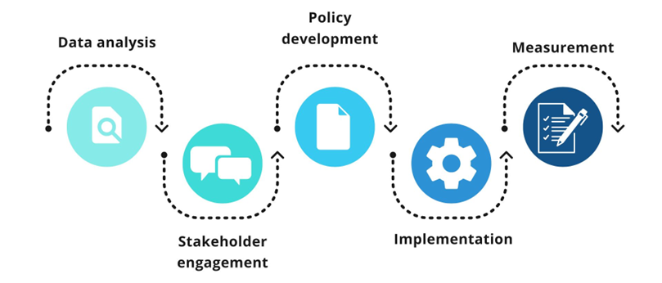
Community-led Approach  Australia | 